Procedure for crane and lifting operation

- Objective : - Safe handling of material with lifting and shifting equipment.
- Scope :- Inside and outside the plant premises
- Ref. : -
SP44, S46, OHSA standards, operation & Maintenance manuals of Hydra crane,
Pal finger crane, Hiab platform, 50MT, 100Mt, 200Mt, 300Mt, 500mt crane
.
- Responsibility : - Engineer In Charge,

PPEs to be used:

Helmet, safety shoes, dust masks, hand gloves and goggles, seat belt, full body safety harness (working at height)

Aspect – impact

Oil Spillage | Land contamination & resource depletion
Oil consumption | Resource depletion
Scrap generation | Resource depletion
Oil traced waste generation | Land contamination & resource depletion
CO2 emission | Air pollution

- Shifting of material from one location to another

Mechanical Hazard
1. Trapping of hand between two objects.
2. Falling of material like hammer, tools, bolts, and steel items.
3. Skidding of person due to poor housekeeping, oil spillage, uneven surfaces, broken bricks etc
4. Back pain while handling sudden or heavy load
5. Cut injuries from sharp edges of items
6. Getting trapped in the collapsed material stacked

Electrical hazard
1. Electric shock from overhead lines

Chemical Hazard
1.Spillage of material
2. CO gas inhalation

Physical hazard:
1. Touching hot material

Human behavior
1. Violation of procedure
2. Person working under alcohol
3. Horse play

Aspect and Impact

Dust Generation | Dust pollution when moving in dusty area

- Manual shifting of material

Max permissible load for 1 person : 25 kgs
Max permissible load for 2 persons : 50 kgs (using proper fabricated “Bhari” with 2 stoppers at the middle)
Max Permissible load for 3 Persons : 75 kg (do)

- Manual shifting of the material has to be done by authorized/trained workmen, under proper supervision, and using all PPE.(gloves, helmet, shoes)
- Supervisor should brief the workmen about the length, shape, weight, possible physical, electrical and chemical hazards of the material being shifted.
- Supervisor should plan and use the safest and shortest route for shifting
- Lift the material by firmly holding the handles provided. Items with out handles should be held in such a way that, his hands /legs will not get trapped while lowering / shifting.
- Use 1” manila rope to tie the material together & tie it properly. Proper knot selection has to be done to avoid slippage.
- Carry the material either on the shoulders or by hands. Keeps safe distance, from hazards like falling in gutters, side pits, hitting vehicles and machinery, etc.
- Ensure that the load is well balanced, in transit.
- Unload the material at the destination point without giving any jerks to your body.
- Take proper care while lifting and lowering the weight, as sudden release can cause back injury or other health hazards
- If more than one person is holding the same load, they should preferably be of the same height
- When 2 persons are carrying any material, and one of them has difficulty in handling the load, he should intimate the other person and together they should lower the load slowly and in rhythm
- While handling long items, care should be taken of overhead electrical lines. If required, isolate the electrical line.
- Stack / keep the material in proper place to avoid obstruction of other jobs / moving vehicles.
- Stack the material to a maximum height of 1.5 mtr only to avoid the hazard of falling of stacked materials. Do not stack materials haphazardly
- Hazardous / Toxic material /chemical should be handled, considering MSDS of the item.

2. Shifting the material by four wheel hand trolley

Hazard
Mechanical Hazard
1. Trapping of hand/s between two objects
2. Fall of material like hammer, tools, bolts, and steel items.
3. Skidding of person due to poor housekeeping, oil spillage, uneven surfaces, broken bricks etc
4. Slipping/Rolling of object from trolley while loading/unloading and during movement on sloppy area.
5. Cut injury due to handling of sharp edged items
6. Hitting of moving vehicles, and machinery in the plant
7. Losing control of trolley on sloppy roads and impact on human body / structure

Human behavior
1. Violation of procedure
2. Person working under alcohol
3. Horse play

Aspect and Impact

Dust Generation | Dust pollution due to movement through dusty area

- Max Permissible load for hand wheel trolley : 500kg

- Supervisor should plan the safest and shortest route to shift the material and explain the same to workmen.
- For all small equipment like gear box, plumber block, bricks etc which cannot roll, the use of four wheel hand trolley is recommended.
- Lock equipment / stack the brick on hand wheel trolley to avoid slipping & rolling hazard.
- While moving in sloppy areas, trolley needs to be held properly to avoid free movement. Use of trolley with brake is recommended while moving material in sloppy areas.
- Ensure proper balancing and equal distribution of the load on all four wheels by keeping the equipment at the center of the trolley platform.
- 2 workmen should push the trolley from the back.
- Care should be taken of moving vehicles / machinery / crane / equipment while moving on the road
- Use chain block/hydra for loading and unloading the material from the trolley wherever manual unloading is not safe.
- Keep stoppers in front of the trolley wheel while parking, loading & unloading.

3. Shifting the oxygen, LPG / DA cylinders by the trolley

Hazard
Mechanical Hazard
1. Trapping of hand between cylinder and trolley / ground / structure
2. Falling of cylinder / trolley / cutting set / spanners etc.
3. Skidding of trolley due to poor housekeeping.
4. Slipping/Rolling of trolley while loading/unloading
5. Rolling of trolley on sloppy roads
6. Overturning of trolley on uneven roads.
7. Falling of cylinders due to improper fixing of protective M.S.chain
8. Fall of cylinder trolley due to failure of wheels
9. Explosion due to impact on the knob
10. Fire

Human behavior
1. Violation of procedure
2. Person working under alcohol
3. Horse play

Aspect and Impact

Dust Generation | Dust pollution due to movement through dusty area
Fire | Air pollution (SP42)

- Supervisor should plan the safest and shortest route to move the trolley
- Cylinder trolley has to be used for shifting, keeping max. two cylinders only
- Cutting set trolley should be used for shifting cylinders only
- Cylinder trolley must be certified by the engineer before its usage & should be tagged
- Take proper care to avoid rolling/slipping hazard of cylinders.
- Use chain to lock the cylinders in trolley
- Two workmen should be engaged for pushing the trolley (from back)
- Take proper care to avoid sudden jerk on uneven roads and uncontrolled movement on sloppy roads
- Keep a stopper in front of the wheels while loading & unloading cylinders from trolley

4. Shifting of material with vehicle (Truck, Tempo, jeep)

Mechanical Hazard
1. Trapping of hand between two objects
2. Slipping and coming under the wheels of the vehicle.
3. Fall of material like hammer, tools, bolts, etc.
4. Skidding due to poor housekeeping.
5. Failure of the clutch / brake
6. Sliding/rolling of the material from vehicle.
7. Jamming of the hand while locking the tempo/truck gates / doors.
8. Fall of the “falka” of truck during movement.
9. Impact of moving / slinged items, overturning / slipping of steel items.
10. Trapping below vehicle due to failure of brake, sudden jerk.
.
Physical hazard
1. Vehicle emission due to movement.
Electrical hazard
2. Electric shock from overhead lines, welding
3. Short circuit due to failure of electrical system
Human behavior
4. Violation of procedure
5. Person working under alcohol
6. Horse play

Aspect and Impact

Dust Generation | Dust pollution due to movement through dusty area
Oil Spillage | Land contamination & resource depletion due to failure of hydraulic system of the vehicle.
Oil consumption | Resource depletion
Oil traced waste generation | Land contamination & resource depletion when rectifying hydraulic/fuel problems
Vehicle emission | Air pollution

Max. Permissible load allowed is the capacity of the vehicle

- Supervisor should plan the safest route to shift the material by a vehicle and instruct the driver & workmen who will be shifting the material, accordingly.
- Use Chain block/hydra for loading and unloading of material from /in to vehicle.
- Do not keep the vehicle on the slope/uneven surface while loading/unloading the material.
- Keep stoppers below the wheels during loading & unloading. Stoppers should be of approved design. Stoppers should be placed after complete stopping of vehicle to avoid slipping of stoppers. Improper stopper positioning may result in injury to the person standing close to the vehicle.
- Care must be taken while stacking/ unloading the stack (fall hazard from stacked material in vehicle & ground). While opening the door of truck, take adequate care to avoid of stacked material. Items like tile, brick may slide during unloading of stacked materials. .
- Use 1 “ manila rope for tying the material to a fixed member
- Ensure that 90% material is inside the body of truck after loading. Position the material inside truck considering the centre of gravity
- Close the side and end covers of the vehicle, if there is no overhang. If there is a 10% overhang of material, tie the material with proper slings and ropes to avoid slipping. Take care of the hand getting jammed during closing / opening of the body gate
- While shifting the material, one should closely supervise the material to check the slipping/ rolling of the material from the stack.
- While shifting heavy structures e.g shell, huge ducts etc Centre of gravity is to be taken into consideration & the whole pathway of shifting to be cleared.
- One engineer is exclusively made responsible for material shifting, who was doing the complete inspection before shifting specially for very heavy structures
- Engine should be switched off during loading & unloading.
- Maximum speed allowed inside the plant is 16km/hr. No overtaking inside the plant premises is allowed.
- Only a valid license holder & trained person are eligible to drive the vehicle.
- Driver should carry out all necessary predriving checks (brake, tyre condition, parking brake, fuel level, brake pressure, reverse horn, safety belt, etc)
- Check the availability of valid documents – RTO registration, Insurance, pollution certificate etc.
- Follow traffic rules of the land
- Driver should be cautious.
- Security should ask driver about direction of route before opening the gate (Sanquelim / Amona side).
- If vehicle is going towards Sanquelim side than right side gate should be opened fully from inside & other gate from outside similarly if vehicle going is towards Marcella, left side gate should be open fully from inside & other gate from outside. Also this should be followed for LMV.
- Exit of heavy vehicle should be restricted from main gate.
- Wear a safety belt
- Wear a helmet when operating the wheel loader, forklift etc.
- Pedestrian first. The driver of the vehicle should always maintain a safe distance from pedestrians.
- Smoking is prohibited
- Use of mobile phone is prohibited, when driving
- Driving under the influence of alcohol is prohibited.
- The driver should always be alert, when driving. Driving, under fatigued conditions, is prohibited.
- Do not play the fool while driving.

Note:- LIFTING ACTIVITIES OF CONTRACTORS SHOULD BE CARRIED OUT UNDER PROPER SUPERVISION AND ALSO ENSURE THAT THERE IS SUFFICIENT VACANT AREA IN THE THE VICINITY OF THE VEHICLE SUCH THAT THE OUT RIGGERS DO NOT TOUCH ANY STRUCUTRE, OBJECTS ETC.

5. Hydra Operation.

Mechanical Hazard
1. Trapping of hand between two objects
2. Sliding and coming under the wheels.
3. Fall of material like hammer, tools, slung items, bolts, and steel items.
4. Impact of moving / slung items, overturning / slipping of steel items.
5. Skidding due to poor housekeeping.
6. Failure of rope or brake
7. Sliding/rolling of material from Hydra.
Bursting of a tyre while moving / during erection
8. Jamming of the hand while locking the tempo/truck gates.
9. Getting trapped below Hydra because of failure of brakes or sudden jerks.
10. Getting trapped between the swing portion & the body of Hydra
11. Getting hurt because of poor visibility
12. Impact of other vehicles
13. Skidding of wheel stoppers
14. Slipping because of poor house keeping
15. Tripping due to poor stacking
16. Impact of boom/load to other structure cable

Physical hazard
1. Vehicle emission.
2. Pressure due to failure of air system/Hydraulic pressurized system during process

Electrical hazard
1. Electric shock from overhead lines, welding
2. Short circuit due to failure of electrical system
3. Electric shock from battery terminal
Human behavior
1. Violation/ negligence of procedure
2. Person working under alcohol
3. Horse play
4. Non usage of PPE like shoes, helmet & safety belt

Aspect and Impact

Dust Generation | Dust pollution due to movement through dusty area
Oil Spillage | Land contamination & resource depletion due to failure of hydraulic system of the vehicle in operation
Oil consumption | Resource depletion
Oil traced waste generation | Land contamination & resource depletion because of spillage during rectification of hydraulic/fuel problems, during process
Vehicle emission | Air pollution

Requirement for hydra operator

Operator should:

- Be physically and mentally suitable for carrying out the operation of the crane
- Operate the crane responsibly and reliably.
- Have a valid heavy duty license, be trained and authorized to operate the crane.
- Be familiar with the operation of the crane.
- Use all PPE (shoes, helmet, and seat belt). Goggles and dust mask to be used as per requirement
- Not be under the influence of alcohol / drugs.
- Operator should inform the supervisor if he is feeling ill or fatigue before operation of the crane.
- Check the tools and tackles used for lifting for damage and certification.
- Operator should check the wire rope and hooks of the crane for good condition. If there is any damage should be informed to company engineer immediately.
- Operator should clearly ask only one person to give the signals for operation of the crane.
- Operator should check the site for overhead cables, obstruction, leveling of the ground, etc.
- Crane operator and the supervisor must both be fully conversant with crane operation and erection signals
- Operator should check the load to be lifted/ shifted.

.

Other legal requirements:

- Insurance for Hydra
- Valid Form 12 certification
- Pollution certificate
- RTO certification
Capacity and maximum lift of the F 15 hydra is specified below.
SWL of Escorts F15 (consider 75% of this figure)
1 st Hook capacity : 5.75 T
2nd Hook capacity : 7.5 T
3rd Hook capacity : 12 T
4th Hook capacity : 14 T
SWL of Escorts C8000 (consider 75% of this figure)
1 st Hook capacity : 1.5 T
2nd Hook capacity : 2.5 T
3rd Hook capacity : 3.5 T
All the above capacities are at Zero length and when boom is in horizontal direction (i.e. O deg) Capacity varies with boom length and angle of tilting of the boom. Refer load chart of the Hydra.
- Supervisor should plan the safe route to handle the material by fork lift and give proper instructions to the operator & the workmen associated with the job
- When starting the machine, inspect the battery terminals, tyre pressure, check brakes, operating brakes, reverse horn, running steering, lights, lowering & lifting operation, and steering movement. Any discrepancy noted must be intimated to the engineer concerned, immediately.
- Always consider 75% of SWL of load chart as safe for handling / lifting. The indicated safe working load varies with boom length and radius and the user must refer load chart before use.
- No crane shall be loaded beyond 75% of rated load except for statutory test purposes
- The hoist rope shall not be wrapped around the load or kinked.
- The safety latch of hook should be in locked position after slinging a load.
- The load shall be well secured and properly balanced in the sling or lifting device, before it is lifted more than a few inches.
- The hook shall be brought over the load in such a manner as to prevent swinging
- During hoisting, acceleration / deceleration of moving load is not allowed. The load should not come in contact with any obstructions.
- Side loading of booms shall be limited to freely suspended loads and Hydra should not be used for dragging the load.
- The operator shall test the brakes each time a heavier load has to be lifted, by raising it a few inches and applying brakes.
- Neither the load nor the boom shall be removed below the point where less than two full wraps of rope remain on rope drums.
- The boom shall be carried in line with the Hydra movement. The empty hook shall be lashed / restrained / retracted to avoid free swing.
- Hydra shall not travel with boom so high, that it may bounce back over the cab.
- Do not travel the crane / Hydra in lifted boom condition as it may hit overhead structures and overhead cables
- The operator should not leave his position at the controls while the load is suspended.
- No person should be permitted to stand or pass under a lifted load
- In case any other lifting / shifting equipment is brought from a different source, the capacity and other details have to be confirmed before starting the job.
- Hydra may be used for loading and unloading purposes only.
- Heavy materials, long fabricated structures, steel plates, pipes, large valves should not be shifted with Hydra.
- Small equipments such as gear box, motor, rollers, bearing bock etc can be shifted with Hydra with very close distance up to 25 mtr under closed supervisory . No one should move along with Hydra. Tying of ropes on the slung item, for guidance, is not permitted The sling should be short enough to restrict swinging.
- Sling the weight so that when lifted, the weight does not swing.
- Ensure that the slinging point is approximately at the centre of the material to be lifted, for proper lifting.
- Use short slings which will fit tightly on the material to be lifted, so that swinging of the object can be avoided.
- Maintain minimum ground clearance while transporting. While moving beneath electrical lines ensures that there is sufficient clearance between the lines and the bucket / boom in the lifted condition. Ensure shutdown of power while working / moving nearby power lines.
- While turning, watch rear end swing, clearance under overhead installations
- Never carry passengers
- Travel at less than 20 KMPH speed.
- Give instructions to crane operator to move the material safely
- Before removing the sling from the lifted member, ensure that the member is safely secured.
- Never weld a lifting hook on hard faced surface or on material whose composition is unknown or different.
- Sling equipment on its standard lifting hook after inspection.
- Hydra should be used only in good visibility conditions and where clearance is ensured.
- Follow best slinging practices while slinging items to avoid slipping / rolling.
- Use certified slings and D shackles of double the capacity of the weight to be handled.
- Driver should carry out all necessary pre driving checks (brake, tyre condition, parking brake, fuel level, brake pressure, reverse horn, safety belt, etc)
- Check the availability of valid documents – RTO registration, Insurance, pollution certificate, Form 12 etc
- Follow traffic rules of the land
- Wear safety belt
- Check reverse horn
- Pedestrian first. The driver should always maintain a safe distance from pedestrians..
- Smoking is prohibited
- Use of mobile phone is prohibited when driving
- Driving under the influence of alcohol is prohibited.
- The driver should always be alert, when driving. Driving under fatigued conditions is prohibited.
- Do not play the fool, when driving.

6. Loading/Unloading and stacking of material with a fork lift.

Aspect and Impact

Dust Generation | Dust pollution due to movement through dusty area
Oil Spillage | Land contamination & resource depletion due to oil leakages.
Oil traced waste generation | Land contamination & resource depletion during rectification of hydraulic/fuel problems during process

Operating hazards while carrying out the activity:

Workplace hazards: ramps, slippery roads, poor lighting, congestion, rail road tracks
Loads: Uneven weights, broken pallets, large or bulky loads, poorly stacked material

Pedestrian: Unaware of fork lift movement, not paying attention, playing the fool.
Mechanical Hazard
• Overturning of the fork lift, operating on uneven surfaces
• Overturning due to loosing the balance and center of gravity.
• Trapping of hand between two objects while stacking/slinging the material
• Coming under the wheels of the vehicle
• Impact of moving / slung items and slipping of items.
• Skidding of machine due to poor housekeeping, oil spillages and soft soil.
• Failure of brakes
• Bursting of tyres
• Getting hit by coming in the swing area of the fork lift
• Getting hurt because of operating in poor visibility
• Impact on other vehicles/buildings/ trees
• Fall of lifted pallets
• Hitting of person while reversing
• Incidents due to poor illumination. Person getting hit by a fork lift.
• Hitting of lifting extension piece.
• Failure of chain
• Failure of mechanical ramp arrangement.
• Collapse of stacked materials.
• Human behavior aspect of operators : Operator’s nature, alcoholism, casual approach & non usage of PPE,

Physical hazard
• Vehicle emission .
• Pressure due to failure of air /hydraulic system

Electrical hazard
• Electric shock from overhead lines or welding
• Short circuit due to failure of electrical system

Human behavior
1. Violation of procedure
2. Person working under alcohol
3. Horse play

OPERTATOR’S DON’TS TO STRICTY FOLLOW

- No smoking while fuelling
- No usage of mobile while driving / fuelling
- Use all PPE’s helmet, safety shoe, goggles / glass and seat belt.
- Never eat or drink while driving
- Smoking is prohibited
- No stunt driving or playing the fool
- No alighting from a running forklift.
- Seat belts & helmets are compulsory

- Only trained & authorized persons should operate the forklift.
- After starting the machine, inspect the battery terminals, the tyre pressure, the brakes, the operating brakes, the reverse horn, the running steering, lights, the lowering & lifting operation and the steering movement .
- Supervisor should plan the safest route to shift the material by a fork lift and should instruct the operator & workmen associated with the job, accordingly
- Maximum permissible speed inside the plant premises is 5 km/hr.
- Driving with raised forks, manouevring the corners too fast, striking low doors or beams, driving across inclines and uneven ground are the main causes of forklifts overturning.
- Colliding with another vehicle, braking too sharply and towing disabled forklifts can also cause overturns and fatalities.
- Fork lift should be operated on leveled ground, Uneven flooring, particularly with a height difference in excess of 40mm across the front wheels, can have a serious impact on a forklift’s stability, when carrying its rated load, at full height.
- Before lifting a load, understand it’s weight & center of gravity. When lifting pallets, inspect the pallet for damage and restack unstable pallets if required. Never place a load on the back of the fork lift to increase it’s capacity. Towing has always to be done with the help of the rear towing pin
- Take proper care to avoid any collision with the overhead structures, Forklifts can easily overturn if they make contact with overhead structures.
- Ensure proper balancing of the forklift by keeping the pallet on fork arm, considering the centre of gravity and stability.
- Fork lift should be used for shifting of rigid completely packed pallets from one location to other location.
- Ensure fork lift steps that give a sound footing, anti-slip surfaces and grab handles to provide three points of contact (hands & feet), while mounting on or dismounting from the forklift
- Always look in the direction of travel. Keep body inside the cage
- While turning, watch the rear end swing and clearance under overhead installations
- Avoid loose objects / holes, If load blocks, travel in reveres, Never carry passengers
- The pedestrian always has the right of the way. Maintain safe distance from the edge of the ramps or docks
- No person should stand under the elevated portion of the fork lift
- Never place a load on the back of the fork lift to increase it’s capacity
- The entire loading and unloading operation should be supervised.
- Ensure forklift operating and parking areas are clear of obstructions.
- Do not jump from the fork lift. Hold on to the wheel, brace your feet, and lean away from the fall
- Lift capacity, that is, the maximum load supported by the lift and vertical lift travel, are the two most important forklift specifications to prevent forklift instability incidents.
- When a load is lifted, the forklift is less stable. A forklift may become ‘dangerously’ unstable when driving with a lifted load or a lifted empty load carriage.
- Driving with a raised load is a dangerous practice impairing stability and easily leads to tip over and turnovers, particularly if the forklift is being driven at speed or around a corner or on an uneven surface.
- Never negotiate turns on ramps or rail loads
- Ascend / descend ramp slowly, Rail tracks are crossed diagonally; Never park within 8 feet of center of rail track roads.

11. Container loading/unloading & stacking

27. While lifting the material, raise the mechanical ramp with the help of the jack provided at both the ends to match the container level. The jack should be operated from a distance to avoid getting trapped between the truck and the ramp. Use tested jacks for lifting/ lowering of ramps.
- Position the trailer parallel to the ramp, and bring it in reverse position, giving signal from a safe distance.
- Release the pressure of the jack, after ensuring that the vehicle is properly positioned.
- Keep stoppers below the truck wheel to avoid movement of truck during forklift entry.
- Ensure that the ramp plate is resting properly on the vehicle, before the fork lift moves on the ramp.
Move the fork lift inside the container,
- Lift the pallet carefully, position back and lower the arm close to the ground level. Move backwards slowly and come out of the container.
- While reversing, keep a watch on the reverse passage / route
- Travel the fork lift through the designated road and stack the pallets
- Once the trailer is unloaded completely, raise the ramp with the help of the jack.
- Slowly move the vehicle forward and give instructions to the other trailer to position it, for unloading.

12. Shifting the material using Pallet trolley

Aspect and Impact

Dust Generation | Dust pollution due to movement through dusty area
Oil Spillage | Land contamination & resource depletion due to oil leakages.
Oil traced waste generation | Land contamination & resource depletion during rectification of hydraulic/Fuel problems during process

Mechanical Hazard
• Trapping of hand between two objects while adjusting the material
• Skidding of trolley due to poor housekeeping.
• Getting trapped in between the swing
• Hitting due to poor visibility
• Overturning of the trolley
• Fall of lifted pallets
• Human behavior aspect of operators : Operator’s nature, casual approach & non usage of PPE

Physical hazard
• Pressure due to failure of Hydraulic system

- If pallets are damaged, remove it with pallet trolley.
- Pallet trolley can be used to shift the pallets from inside to the door side.
- Place the pallet trolley below the pallet.
- Raise the platform by hand pump, and move the pallet trolley backwards.
- Transfer the pallet to the fork lift, which is positioned in front of the container.
- Move the pallet trolley back to inside.
- Forklift can now lift and stack the pallet s.
Human behavior
1. Violation of procedure
2. Person working under alcohol
3. Horse play

13. Shifting & erection of material using truck mounted Pal finger crane

Mechanical Hazards

1. Person getting hit by the crane boom, while hooking the object.
2. Lifting of the truck due to unstable loading.
3. Hitting of the slung object & crane boom on the truck cabin, during swinging of boom
4. Trapping of hand between two objects
5. Coming under the wheels of the vehicle by slipping.
6. Fall of material like hammer, tools, bolts, and steel items.
7. Impact of moving / sling items, overturning / slipping of steel items.
8. Skidding / slipping due to poor housekeeping.
9. Failure of brakes
10. Sliding/rolling of material from crane.
11. Bursting of tyre while moving / erection
12. Jamming one’s hand while locking the truck gates.
13. Coming under the truck mounted crane due to failure of brake or sudden jerk.
14. Getting trapped between swing portion & body of crane
15. Hitting due to poor visibility
16. Impact of other vehicles
17. Skidding of wheel stoppers
18. Hitting on surrounding structures, while negotiating a turn.
19. Fall of the Pal finger crane from the truck due to failure of mounting bolt.
20. Hitting of extended end support stopper
21. Failure of hydraulic system
22. Failure of hook of the crane
23. Fall of the “falka” of truck during movement.
24. Hitting of the boom due to fast operation.
25. Tripping due to poor stacking.
26. Fall of the extended boom from top.
27. Damage of overhead structure during marching.
28. Hitting / trapping of crane due to improper / non sequential operation
29. Bending of chassis due to non leveling of stabilizers
30. Failure of stabilizers
31. Failure of crane / chassis due to non leveling of crane platform with water level
32. Non usage of PPE– like shoes, helmet & safety belt
33. Improper operation due to improper signaling.

Physical hazard
1. Vehicle emission.
2. Pressure due to failure of air system/Hydraulic pressurized system during process

Electrical hazard
1. Electric shock from overhead lines or welding
2. Short circuit due to failure of electrical system
3. Electric shock from battery terminal
4. Improper laying of overhead cable
Human behavior
1. Violation/ negligence of procedure
2. Person working under alcohol
3. Horse play

Aspect and Impact

Dust Generation | Dust pollution due to movement through dusty area
Oil Spillage | Land contamination & resource depletion due to failure of hydraulic system in vehicle during process
Oil consumption | Resource depletion
Oil traced waste generation | Land contamination & resource depletion during rectification of hydraulic/fuel problems during process
Vehicle emission | Air pollution

Requirement for crane operator

Operator should:

- Be physically and mentally suitable for carrying out the operation of crane
- Operate the crane responsibly and reliably.
- Have valid heavy duty license, be trained and authorized to operate the crane.
- Be familiar with the operation of the crane.
- Use all PPE (shoes, helmet, and seat belt). Goggles and dust mask to be used as per requirement
- Not be under the influence of the alcohol / drugs

Crane operator and the supervisor must both be fully conversant with cranes operation and erection signals
13.No Negligence or over confidence while driving

Other legal requirements:

- Insurance for crane
- Valid Form 12 certification
- Pollution certificate
- RTO certification for crane

Operation of the Pal finger crane

- The supervisor should explain the job before the start of the job.

- Preliminary checks:
  - Visual checking for external visible defects, damage and changes.
  - Checking of pedal brake and hand brake for proper functioning.
  - Functioning of electrical systems including all lights, reverse horn, parking light, head light etc.
  - Check for any loose hose connections and other hydraulic fitting leading to leakages. Leakage of hydraulic fluid increases the danger of accident and cause serious and costly environmental damage.
  - Easy movement and self return of controls.
  - Load lifting parts, ancillary equipment, lifting hooks, hooks securing devices, for any crack damage and easy movements. If such defects are observed, the crane must not be started up.
  - Check the functioning of “Emergency off”. Overload safety devices / alarm etc .If safety equipment fails to respond, the crane must not be started up.

- Guideline for Parking / Positioning of crane:
  - The ground should be level
  - Compactness of ground. Do not keep the crane in soft soil
  - Check free movement of crane boom in the working area.
  - Other peoples working near by area are not affected by crane movement/operation.
  - Access to the job
  - Visibility of operation

- Keep the truck in “ON” position,
- Apply hand brake & keep the gear to neutral position
- Fix mechanical stopper below both front tyres of truck
- Connect the PTO, pressing the clutch and moving the PTO knob.
- Switch “ON” the hydraulic pump
- Operate the front extendable out triggers first and level the front portion of the crane by moving cylinders vertically
- Operate the back extendable out triggers first and level the crane by moving cylinders vertically.
- Check the “spirit level” and adjust the out rigger cylinders to make the crane in perfect horizontal. The air bubble of “spirit level” will match with innermost circle when the crane is balanced. Crane inclination is 0 to 5 deg if the bubble is between the inner and outer circle.
- The out riggers should be lifted to reduce the load on all wheel of truck
- Do not place the outriggers on drain slab / man hole cover / loose surface.
- Keep the out riggers fully open to avoid overturn of crane.
- Activate the crane function, grip the operating lever completely and move slowly and evenly. Abrupt crane movements such as quick activation and momentary stoppage can cause damage to crane.
- Extend the main boom cylinder first (to unfold the boom) so that boom comes out of the mechanical stopper. Operate the lever smoothly to take out boom out of the mechanical stopper. Avoid the sudden jerk during initial stage. Use the hand lever away from boom tip to avoid impact of boom
- Operate the second boom to achieve suitable height reach.
- Once the boom is taken to the sufficient height, rotate the main post to the suitable location of the object. (Boom has 480 deg rotation capacities.)
- The crane is most unstable when the boom is above the front cabin area.
- Hook the object suitably, using a sling and carry out the loading/unloading operation. DO NOT STAND BELOW THE SUSPENDED LOAD.
- Move the raised load inside the truck with care so that it does not hit against the crane and other structures.
- The crane operator is not allowed to carry out any other job. If operator himself is to remove the load, then he should press the emergency switch off before leaving the position.
- Loads to be attached or removed after complete stoppage of crane motion.
- The rigger should come out of crane swing area before moving the crane fro next operation.
- Operate one function at a time.
- Do not load the crane when “overload buzzer” activates
- If the crane gets loaded beyond its capacity , following operation becomes disengaged

Main Boom - Lowering
Outer boom - Lowering/raising
Extension boom - Extension.

In such a case, reduce the load moment by retracting the extension boom. The crane functioning becomes normal once the load is in the safe capacity of crane boom
- Once the job of loading is completed, retract the boom to its original position and ensure that the second arm is locked in the mechanical stopper and also extended boom is locked in the locking plate. This will keep the boom of the crane in position, during transit.
- Retract extension support cylinder & out riggers at back first and then at front
- The outriggers and support cylinders should be retracted and fully secured before any movement of crane.
- Switch “OFF” the hydraulic pump.
- Disengage the PTO to operate the truck.
- Remove the mechanical stoppers
- Release the parking brake by keeping the pedal brake activated.
- The track may now be moved to another location
- Ensure that the load is secured firmly in the bucket and does not protrude out of the vehicle or fall outside the vehicle.

Specific safety requirement for Pal finger crane

General safety instructions

1. Safety devices should not to be tampered with, under any circumstances.
2. Keep safe distance from the crane, during operation /movements.
3. Be alert to faults, during crane operation.
4. This truck has an additional load of the crane and the length of the truck is more than the usual truck. Drive the vehicle with more attention
5. The crane is projected above the cabin. Keep a watch on the overhead structures/safety barriers.
- While driving the crane it is to be ensured that electrical overhead cables are laid properly,anyway it will not touch the crane boom
- Never move the vehicle with stabilizers out
- Never move vehicle with boom lifted position. The boom should be completely retracted, folded and positioned to rest position
6.

Prior to crane operation

1. Check the safety devices before start up.

On Start Up

1. Slope of the vehicle should not exceed 2 deg in any direction during loading/ unloading of the material.
2. During loading/ unloading outriggers must be fully extended.
3. When extending outriggers and support cylinders, observe the safe distance.
4. If necessary, enlarge the support surface according to the condition of the ground.
5. Vehicle must not be raised using the supports. Supports should only take the load with all tyres of vehicle touching the ground.
6. Lock manually extendable outriggers properly before loading/unloading.
7. Prevent the support from sinking into the ground
8. Before unfolding the crane mechanical extension has to be secured properly

During crane operation

1. Ensure the crane is used according to the specification for handling loads. Mechanical interventions (pushing or driving against obstacles), fastening of the load at point other than provided for the purpose, pulling of loads, etc are prohibited.
2. Always keep an eye on the working area
3. Do not stay in the danger area of the crane.
4. Safeguard the working area
5. Select the right control stand.
6. Adhere to the maximum lifting capacity of the crane, ancillary equipments and load lifting gears.
7. No load moment increase when lowering the load.
8. Crane should not to be operated if wind speed is more than 50 km/h and ambient temperature out of limits (-30 deg C to +50 deg C).
9. The control valve, all other valves, hydraulic lines and hoses, hose couplings, hydraulic cylinders etc. may become hot & can cause burn injury.
10. Crane should be operated by one person from control stand only
11. Park the vehicle properly and apply the handbrake
12. During the loading or unloading process, the crane operator should not leave the crane control valve
13. When the main boom is below the horizontal line, the maximum lifting power cannot be reached.
14. Never use the crane without support of outriggers
15. Secure the crane in transport position before moving the truck
16. Observe safe distance when retracting the outriggers and support cylinders.
17. Lock the manually retractable outriggers in the retracted position.
18. Check the outrigger locking device before every trip
19. Observe maximum head room on the bridge and tunnels

14. Shifting & erection of material using truck mounted HIAB crane / workmen basket

The Operation of the HIAB crane is similar to that of the Palfinger crane. Additional precaution to be taken for operation of the HIAB crane has been listed below.

IMPORTANT NOTE FOR OPERATION OF HIAB CRANE

- Check the condition of the whether before operating the crane. Crane should never be used in high wind or storm when wind velocity exceeds 13.3 m/s (48km/hr) the crane will behave unpredictably
- HIAB crane is provided with the overload protection. When the load is close to the rated capacity, the indicator light will flash as a warning. Once the rated capacity is reached OPL (overload protection) will cut off the crane movement. in such case, move the lever to the neutral position and then operation will be available for load reducing functions only.
- Always use hydraulic extension boom, The use of manual boom is restricted for basket only.
- Crane should be operated in day light only for workmen basket application..
- Transport of the crane is permitted in folded condition only
- No material to be lifted without using stabilizer

Aspect and Impact

Dust Generation | Dust pollution due to movement through dusty area
Oil Spillage | Land contamination & resource depletion due to failure of hydraulic system in vehicle during process
Oil consumption | Resource depletion
Oil traced waste generation | Land contamination & resource depletion during rectification of hydraulic/fuel problems during process
Vehicle emission | Air pollution

Hazard for HIAB crane in addition to that of Palfinger crane

1. Failure of the basket structure
2. Fall of person from height due to unbalance
3. Trapping of the person between basket and structure.
4. Fall of basket due to failure of the clamping.
Human behavior
1. Violation of procedure
2. Person working under alcohol
3. Horse play

FOR USAGE OF THE WORMEN BASKET

Details of Basket
Sr.No. : 7134
Model : SP 800
Max. Load allowed in basket : 220 kg
Weight of Basket : 94 kg
Total Weight : 314 kg
Max. No of person allowable : 2 no
Manufactured : Sept / 07

- Check the structural stability of the boom hooking position for any damage by visual inspection.
- Locate the boom as close as possible to the horizontal position, but low enough to reach extension by hand.
- Stop the crane by pressing the stop button
- Remove the locking device and locking pin of the manual extensions.
- Extend the manual extension as per the requirement
- Fix the manual extension by locking the pin and locking device. Make sure that locking device is properly locked.
- Ensure that the pads are available on both top and bottom of the crane.
- Check the condition of the basket and proper functioning of the spring brakes of the basket to avoid overturning
- Engage the basket suitably to the crane boom
- While operating the crane , the operator may stand below or stand inside the basket along with the other workmen and both should wear the safety harness
- Concern engineer in charge of the job should stand at the control panel of the crane so attend any emergency in case of the remote control is not operating.
- Carry out the activity of material handling.
- While removing the basket take the boom as close as possible to the horizontal position but low enough to reach extension by hand.
- Stop the crane by pressing the top button.
- Dis-engage the basket from the boom by removing the pins
- Retract the manual extension fully by hand
- Fix the manual extension by locking the pin and device. Make sure that the locking device is properly locked.
- Never move the vehicle with stabilizers out
- Never move vehicle with boom lifted position. The boom should be completely retracted, folded and positioned to rest position

15. GENERAL INSTRUCTION TO BE FOLLOWED WHILE SHIFTING AT DIFFERENT LEVEL
- Entire shifting operation shall be done under close supervision, so as to avoid damage to the other plant structures and personnel.
- Identify the material to be shifted, estimate the approximate weight of the same and select proper slings / lifting tools.
- Ensure that the lifting tools such as chain pulley blocks, wire rope slings are certified for safe use and are of the rating exceeding at least twice the weight of the material to be lifted.
- Ensure the soundness of the structures where the shifting is being carried out, do not lift / shift material weighing more than 25 Kg manually, & through walkways and stairways.
- Do not use the hand railings as support for lifting the material.
- If the permanent arrangement for hanging the chain pulley block does not exist, a permanent structural member shall be identified by the area in charge and inspected for its safe use, considering the weight of the material to be lifted.
- Check the structural member and hook for adequacy of weight to be lifted. Corroded/weak structures should not be used for hooking. The number of lifts required to carry out the lifting should be decided considering the height of the installation and available lift of the chain pulley block. Intermediate resting place should be inspected and checked for stability, by the area in charge. Cordon off the work area at the ground level. Before lifting of the material, guy ropes shall be tied at appropriate position on the material, to avoid swinging of the material and damage to the surrounding areas,
- The operator is not permitted to leave his position at the controls, while the load is suspended.
- Ensure that the personnel working are conversant with the use of lifting tools and material lifting.
- The operator should not move any suspended load above working people.
- All material used for shifting should be removed after completion of the job and shifted to the storage place
- Derricks may be used for lifting materials where there is no provision to fix chain pulley block / access for Hydra. All derricks should be certified with design department prior to use. This decision will be taken by the Manager Maintenance in consultation with the design department

16. GENERAL INSTRUCTIONS TO BE FOLLOWED FOR LOADING/UNLOADING OF MATERIAL
- Material which has weight less than 50 Kgs.

  - Loading/unloading of the material has to be carried out manually, taking all safety precautions like usage of all PPE and under close supervision.
• Analyze the condition of the object to be manually handled for ease in shifting.
• Use proper hand gloves for shifting any material by hand.
• Do not handle material weighing more than 25 kgs per person, manually.
• Do not handle long overhung material by hand.

- Material which has weight more than 50 Kgs:

• Loading/Unloading can be done by chain pulley block / hoist / Hydra
  - Usage of chain pulley block
1. Assess the condition of the hook & hook welding to structure where chain block will be hooked.
2. Check for the safe working load of the hoist and its certification .
3. SWL and next due date for checking should be mentioned on the chain pulley block.
4. The weight of the material to be lifted should be below SWL and the sling used should be of higher capacity than SWL.
5. Carry out the inspection of below parameters of the chain block prior to using.

Sr. No. | Description | Type of inspection | Permissible Limit
1 | Inspection of hook and safety latch | Visual | 5% wear
2 | Inspection of wire rope | Visual | No damage
3 | Inspection of the top and bottom hook and its locking bolt | Visual | 5% wear
4 | All fasteners and joints | Visual | For tight fitting and in good condition
5 | Hand chain wheel | Visual | Wheel must not be cracked or damaged and chain pocket must be in good condition

6. Check for proper slinging of the material, by properly centering the material under the chain block. Use correctly rated certified sling as per requirement of the material.
7. Carry out the job under close supervision.
8. The load movement shall be done smoothly without jerking or sudden stop.
9. Chain pulley block is designed to lift loads vertically and should be used only for vertical load lifting.
10. Never drag the load
11. After completion of job, keep back tools in the designated position.

  - Usage of Hoist :

1. Check for the safe working load of the hoist .
2. SWL and next due date for checking should be painted on the hoist.
3. Conduct pre operation inspection of the hoist for damage or wear as given below. Carry out the operation one by one to check the performance and working of safety devices, for all motion.

Sr. No. | Description | Type of inspection | Permissible Limit
1 | Inspection of hook and safety latch | Visual | 5% wear
2 | Inspection of the Brake lining | Visual | Should be good
3 | Inspection of wire rope | Visual | No damage
4 | All fasteners and joints | Visual | For tight fitting and in good condition
5 | Hoist trolley wheels and tie bolts | Visual | No damage & 80 % wheel should be on beam flange at both sides through out
6 | For trolley runner | Visual | no crack, damage or worn out
7 | Hand chain wheel | Visual | Wheel must not be cracked or damaged chain pocket must be in good condition

4. Check for proper slinging of the material by properly centering the material under the hoist and locking in the hook of the crane with safety latch. Use correctly rated certified sling .
5. Check for the healthiness of limit switch by operating the hoist without load.
6. The weight of the material to be lifted should be less than the SWL of the hoist and the sling used for lifting should be of higher capacity than the SWL of the hoist.
7. Only trained, competent, physically fit and properly authorized operators are permitted to operate overhead traveling hoist.
8. All trained operators will be provided training in operation of hoists and their names will be included in the master list of operators competent for operation of hoists.
9. Operator should get themselves familiarized with all the safety operating instructions, before carrying out the operation.
10. The communication between the hoist operator and hoist attendant slinger / rigger, should be as per standard codes or mutually agreed codes. Operator should check the competency of the slinger for adequate knowledge of safe handling method & proper knotting, slinging etc.
11. While signalling is done onely one person should give the signals and the same should be communicated to the operator prior to the operation of hoist.
12. Hoist operator is responsible for the safe operation of the hoist and other safety requirements & hoist.
13. Carry out the desired job under close supervision with minimum speed. Running into the load at full hoisting speed imposes excessive overload on the hoisting member and damages the parts.
14. The load movement shall be done smoothly without jerking or sudden stop.
15. Hoist is designed to lift loads vertically and should be used only for vertical load lifting.
16. Never drag the load.
17. After completion of the job, Park the hoist at the designated location in no load condition so that it will not affect the working of others.

17. GENERAL INSTRUCTIONS TO BE FOLLOWED FOR STORAGE OF MATERIAL

Mechanical Hazard

1. Fall of material like hammer, tools, slinged items, bolts, and steel items when kept on sloppy area
2. Skidding due to poor housekeeping.
3. Sliding/rolling of stacked material
Human behavior
Human behavior
1. Violation of procedure
2. Person working under alcohol
3. Horse play

Aspect and Impact

Dust Generation | Dust pollution due to movement through dusty area

- Do not restrict the ways of general walking/working.
- Maximum allowable height of stacking is 1.5mtr from the ground.
- When stacking one over the other, the material may slide or skid over, and cause injury.
- Stack properly with good housekeeping to avoid the hazard of slipping/rolling down.
- Oil/grease at site location, should be kept in fire resistant covered container.
- Stored material should not obstruct the light, sprinkles and other fire extinguisher equipment, aisle, exits or electrical switch points.
- Material which could cause hazardous reactions shall be kept segregated in storage and marked with appropriate warning sign.
- Cylinders to be stored as per standard color coding and away from combustible material.

18. Usage of hired crane
_____________________________________________________________________

Ø Objective : - Safe erection and dismantling of structures / equipment in the plantScope : -
Ø Ref. : - Crane manual
Ø Responsibility : - Engineer In-charge & Contractor supervisor

PPE –s to be used : Helmet, Safety shoes, hand gloves, dust mask,
Hazards identified

Mechanical Hazard

- Person getting hit by the rear counterweight of the crane while swinging.
- Fall of fly-jib from height during erection / dismantling.
- Hitting of manual boom on person/hydra during extension/retraction.
- Fall of crane hook from the wire rope.
- Fall of material/Tilting of crane due to overloading/violation of working load as per load chart.
- Fall of fly jib locking pins from height on a person while removing/fitting.
- Hand cut/injury due to pulling of wire rope.
- Fall of person from crane boom while working at height/walking.
- Hand injury while placing the wooden blocks below crane stabilizers.
- Person getting hit by the crane boom, while hooking the object.
- Failure of brakes.
- Sliding/rolling of material from crane.
- Bursting of tyre while moving / erection.
- Getting trapped between swing portion & body of crane.
- Fall of the extended boom from top.
- Damage of overhead structure during marching.
- Hitting / trapping of crane due to improper / non sequential operation.
- Failure of stabilizers.
- Failure of crane / chassis due to non leveling of crane platform with water level.
- Human error.
21. Human behavior aspect of operators : Operator’s nature, casual approach & non usage of PPE
- Alcoholism.
- Damage due to operation of crane by crane helper/mechanic.
- Losing control of crane operation due to calls through mobile

Physical Hazard

1. Vehicle emission.
2. Pressure due to failure of air system/Hydraulic pressurized system during crane operation.

Electrical Hazard
1. Electric shock from overhead lines.
2. Short circuit due to failure of electrical system.
3. Electric shock from battery terminal.
4. Electrical shock from welding

Requirement for crane operator

Operator should:

- Be physically and mentally suitable for carrying out the operation of crane.
- Operate the crane responsibly and reliably.
- Have valid heavy duty license, be trained and authorized to operate the crane.
- Be familiar with the operation of the crane.
- Use all PPE (shoes, helmet, and seat belt). Goggles and dust mask to be used as per requirement.
- Not be under the influence of the alcohol / drugs.
- Crane operator and the supervisor must both be fully conversant with cranes operation and erection signals

Legal & other requirements:

- Operators licence – Heavy duty.
- Insurance for crane.
- Valid Form 12 from competent authority.
- Authorization of competent authority form factory inspector of Goa
- Pollution certificate.
- RTO certification for crane – RC book.
- ESI/PF for crane operators.
- Insurance for person.
- Health card and police verification to be done at Goa.
- Crane load chart
- Normal sight for both eyes
- Minimum 3 years experience in crane operation

- Check the crane condition visually for any damage.
- Check the crane wire rope condition, hook condition, hook latch shall be spring loaded, wire rope bull dog clamps tightness, hydraulic hoses, outriggers, crane tyre condition, fly jib condition, etc.
- Check all the legal documents listed above and ensure that the registration number on the crane and the documents is the same.
- Check the operator license and validity. The operator shall have a valid heavy duty license issued by competent authority.
- Check the crane load chart and ensure that the crane make & model is matching with the make and model mentioned on the load chart.
- Ensure that the crane is strictly loaded as per the load chart only.
- Crane should be rigid, reasonably new and reliable
- The swing area of the crane should bebarricated. So that no person are hit when the crane is in operation.
- Never operate the crane when the persons are inside the board of the vehicle.
- Ensure no one is in the swing area of the boom/ load
- Always ask only one person to give the signal.If there is confusion due to mis signally than the job should be stopped and explain the person correctly about signally.
- Do not move vehicle by making the person seat behind the carrier.
- No person should seat inside the vehicle when the operation of crane is in progress

Extension of manual boom and erection of fly jib:

- Position the crane in an open space and park it by extending the outriggers.
- Rest the crane hook on the ground and remove the bull dog clamps and the wire rope.
- Sling the extreme end of the mechanical boom by using minimum 5 T polyester web sling (use higher capacity sling if weight of fly job is more than 3.5 tons)
- Keep the hydra at minimum 3 meters away from the manual boom and put the sling on the hydra hook.
- Slowly load the manual boom of the crane with the hydra and move the hydra in reverse direction to extend the crane boom. Ensure that no person is standing in the vicinity of the hydra and the crane boom. Ensure that there is proper coordination between hydra operator and the crane operator during this activity. Proper signaling shall be done for stoppage of the activity in case of any abnormality.
- Fully extend the manual boom and lock the same with the hydraulic boom with pin, lock pin and spilt pin. Engineer shall ensure that this pin is properly locked.
- Erect the fly jib with hydra and fit the same on the manual boom by inserting 4 pins and split pins. Engineer shall ensure that all the 4 pins are properly locked.
- Put the wire rope over the fly jib pulley and fix the single rope ball hook and lock the wire rope with bulldog clamps. Ensure that the bulldog clamps are properly tightened.
- Lift the hook by operating the crane and take trials by hoisting and lowering the hook. Ensure that the fly jib pulley is freely rotating.

Retraction of manual boom and dismantling of fly jib:

- Position the crane in an open space and park it by extending the outriggers.
- Rest the crane single wire rope ball hook on the ground and remove the bull dog clamps and the wire rope.
- Sling the fly jib in the center and load it with hydra hook. Remove the 4 lock pins split pins and remove the lock pins one by one using a hammer. Ensure no person is standing below the fly jib to avoid fall of fly jib pins on the person.
- After all the 4 pins are removed, remove the flyjib with hydra and keep it at the side on the ground.
- Pass the wire rope from the mechanical boom pulley and fix the ball hook to the wire rope.
- Remove the manual boom locking pin and apply grease on the manual boom.
- Now fix the ball hook to the front sling of the main crane which is used for holding the main hook when the crane is being transported.
- Slowly load the wire rope so that the manual boom of the crane just slides in the hydraulic boom. Retract the manual boom by slowly loading the wire rope by the crane operator. Ensure that no person is standing in the vicinity of the crane and the crane boom. Ensure that there is proper coordination the crane operator and the crane helper during this activity. Proper signaling shall be done for stoppage of the activity in case of any abnormality.
- Put the wire rope over the crane pulley after fully retracting the mechanical boom and fix the main hook and lock the wire rope with bulldog clamps. Ensure that the bulldog clamps are properly tightened.
- Lift the main hook by operating the crane and take trials by hoisting and lowering the hook.

PREFERED MODE OF SHIFTING (FOR REFERANCE ONLY)
*SUBJECT TO THE CONDITION AT THE SITE.

Sr. No. | Material | Recommended shifting Method | Material (Example)
1 | Small equipments, objects with weight less than 25 kg | Single Person Manual Handling | Rollers, Brackets Bearings, Plummer blocks etc
2 | Small Equipments, structure with weight less than 50 kg & long in size | Two Persons Manual Handling | ISA 50X50X6, Bar 32 mm etc.
3 | M.S. Angles, Rods with weight less than 75 kg | Three Persons Manual Handling | ISA 50X50X6, Bar 32 mm etc.
4 | Small Equipment with weight less than 500 kg and not cylindrical (For less distance shifting) | Four wheel Trolley with 2 Persons | Chain block, Gear box, motor, hydraulic and pneumatic cylinder, ladle bricks etc
5 | Oxygen – DA / LPG cylinder | Three wheel Cylinder trolley with lock chain | LPG, DA & Oxygen cylinder
6 | Equipment, Structure, which are not cylindrical & short in size (For long distance shifting) | 4 Wheel truck, Tempo, Pal finger crane | Welding machine, Chain block, Brackets, Bricks, Pig mould, cut scraps etc
7 | Structure for with large weight and long size | Pal finger crane , 6 wheel truck for shifting and Hydra for loading/unloading | Plates, Beams, Pipes, Channels, structures, HBV, chimney valve etc.

Working near Electric lines :

While working near the electricity line following minimum distance between the crane and electric lines to be maintained unless line is being under proper electrical shutdown

Voltage | Minimum distance to an insulated conductor | Minimum distance to an un insulated conductor
<500 V | 0.5m | 2 m
500-40000V | 1.5 m | 4 m
>40000V | (Not Found) | 6 m

Sling Load chart

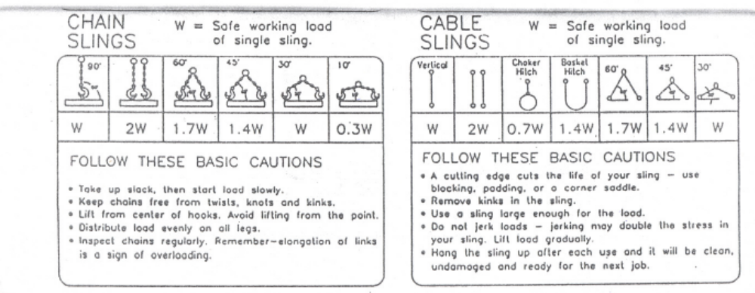

General Load chart for F15 crane
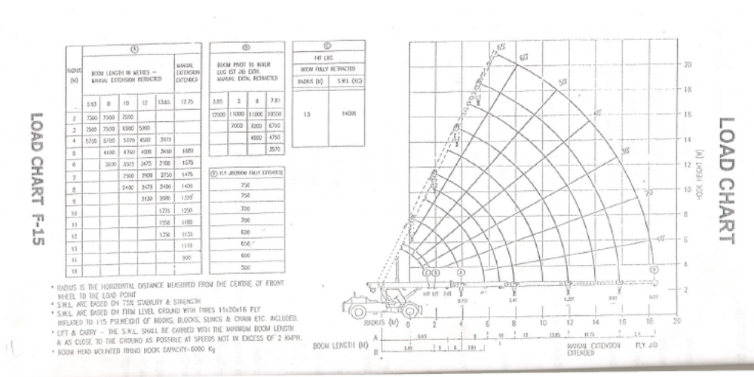

General Load chart for 120MT movable crane
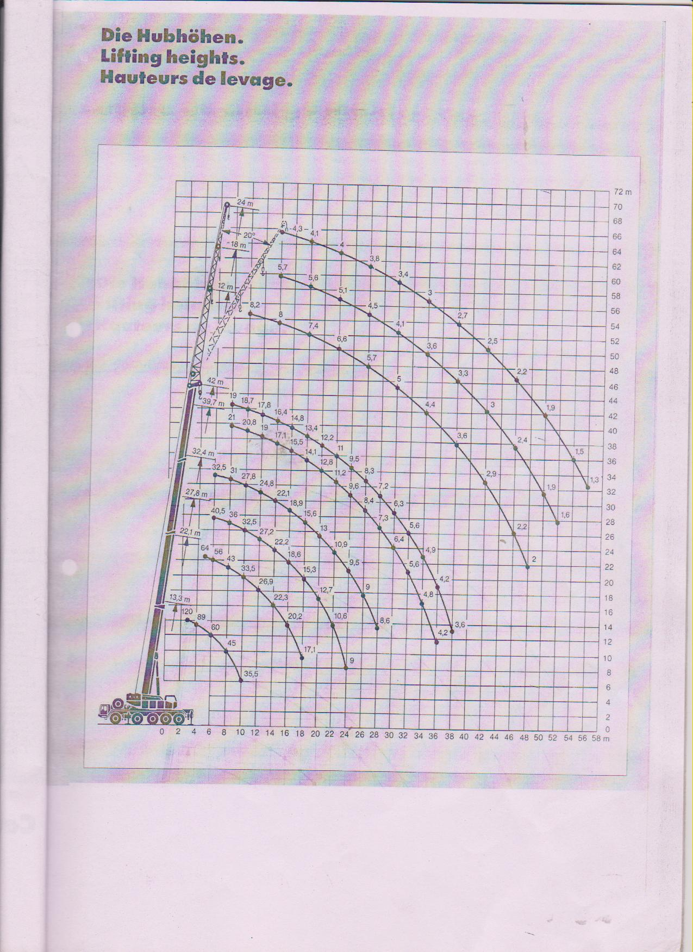
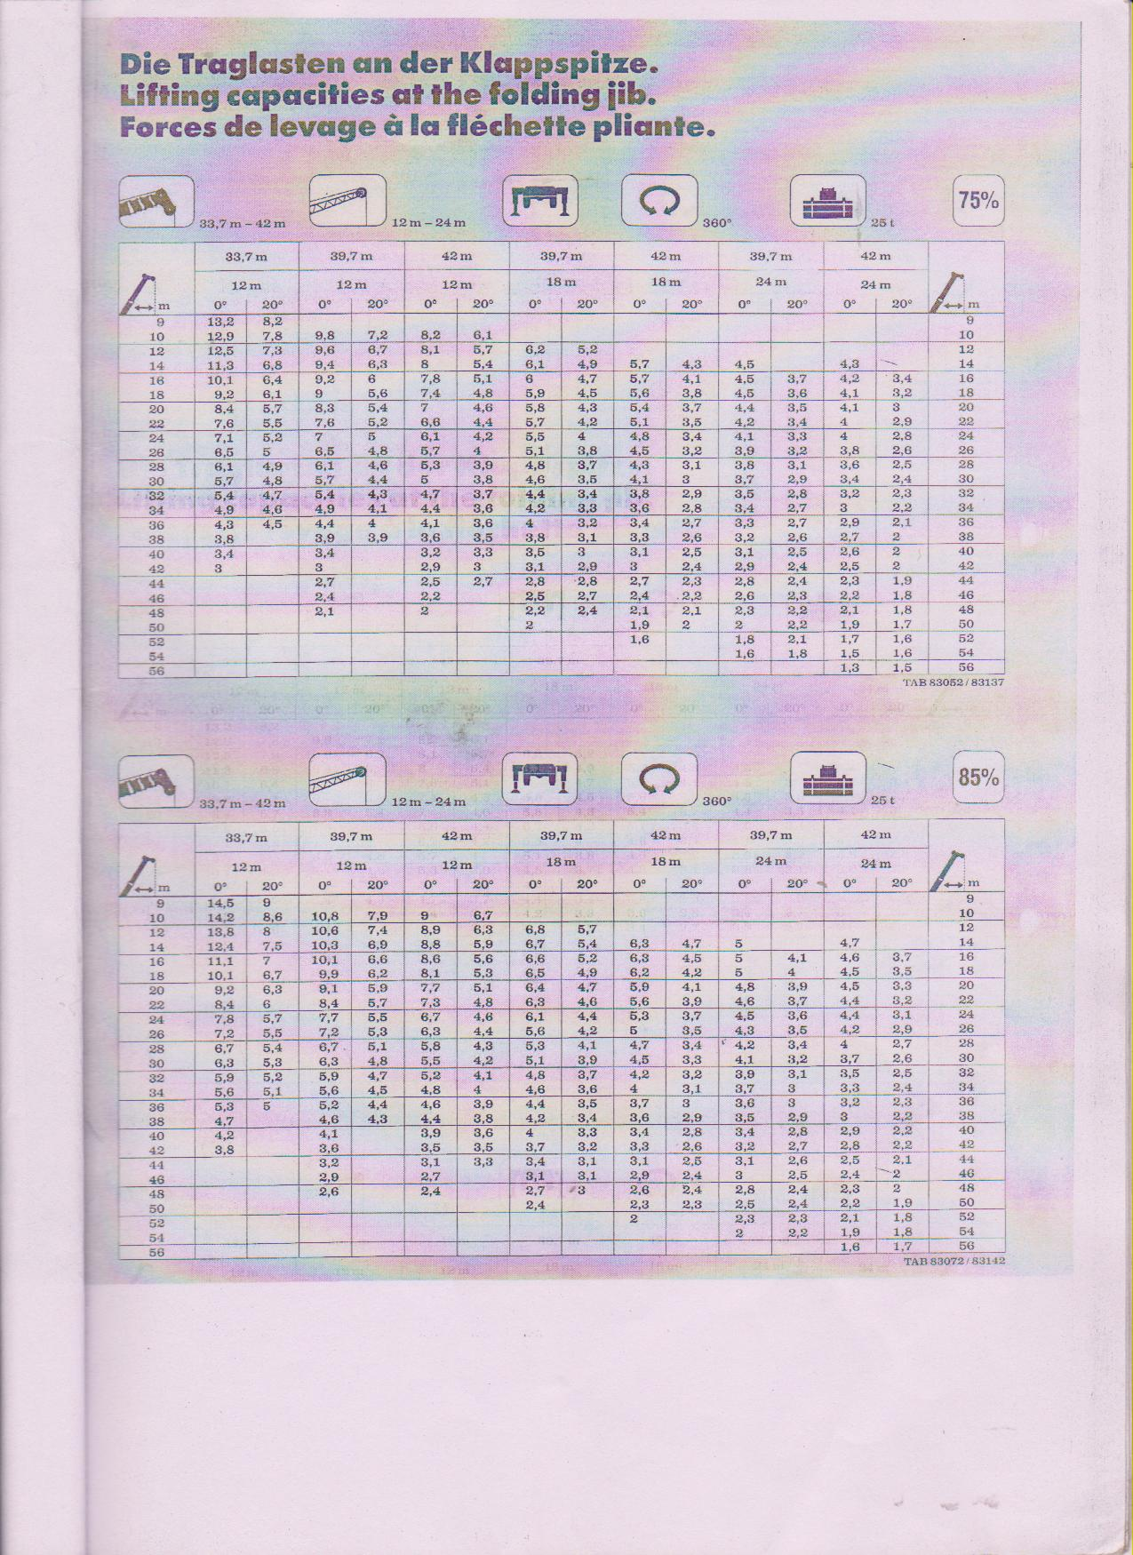

Amendement Record
Date | Manual Section Ref. & Para | Brief details of Revision | New Rev.

Prepared By: HEAD MECH PP | Reviewed & Issued By:  Management Representative | Approved By:  HEAD O&M PP
Signature | Signature: | Signature:
Review Date: 26-08-2023 | Review Date: 26-08-2023 | Review Date: 26-08-2023

